Life on Earth

Earth Science Study Guide Study GUide

Biological Communities

Study Tip

Population and Species

To remember the different between biotic and abiotic factors, know that the prefix “a” before a word means *not*. So if biotic factors are living, then abiotic factors must be non-living.

A **population** is the collection of all members of a **species** (a single type of organism that can interbreed and produce offspring) in a given place and time. A biological **community** consists of multiple **populations** in an area.

Ecosystems

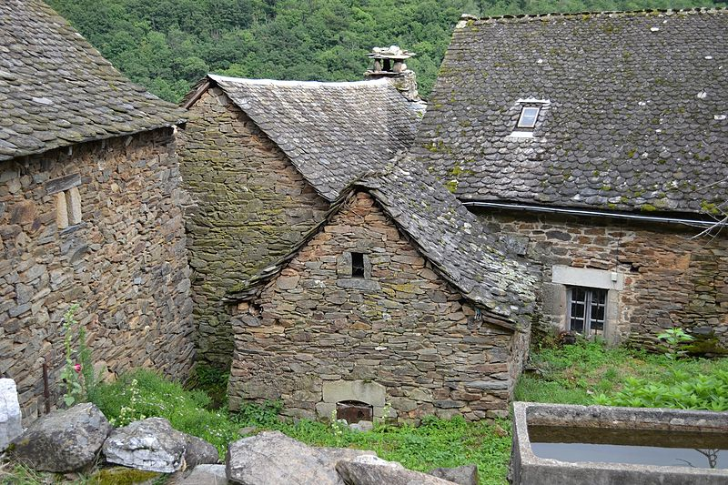**Ecosystems** are biological communities consisting of living organisms, or **biotic factor**s, and their environment, or **abiotic factors**. Examples of **biotic factors** are living organisms such as bacteria, algae, fungi, plants, and animals. **Abiotic factors** can be physical or chemical features such as light, nutrients, water, oxygen, and carbon dioxide.

*A house is an example of a habitat for humans.*

Habitat and Niche

A **habitat** is where an individual lives. Climate, food, water, and weather are all important factors in an organism’s habitat. A **niche** (pronounced *neesh*) is an organism’s position within its environment. For example, a lion is a carnivore at the top of the food chain.

Concept Check

* What are biotic and abiotic factors?
* What is the difference between a species, population, community, and ecosystem
* What is a niche?